SAR - FAMU Career Assistant

Requirements

1. Functional Requirements
- Student profile: Create/update profile with major, interests, and skills.
- Resume upload: Upload a PDF/DOCX; the app reads the text.
- Pull skills: The app picks out skills/keywords from the resume text.
- Job matches: Show a Top 5 list with a match % and short reasons.
- Job details & apply: Open a details view and provide a link to apply (Handshake later).
- Filters/search: Let me filter by role/location and search by keyword.
- Events: Show FAMU career events (name, date/time, location, RSVP) and let me save them.
- Alerts: Notify me about high-match jobs and deadlines coming up.
- Tracking: Let me mark jobs as Saved/Applied/Interview/Offer/Rejected and add notes.
- Mock data admin: Import/update jobs and events from CSV/JSON.

2. Non-Functional Requirements
- Performance: Matches load in ≤ 3 seconds; resume scoring in ≈ 1 second.
- Security/Privacy: Mock/anonymized data only; limit file types/sizes.
- Reliability: Core flow (upload → matches → details → alerts) works consistently with friendly error messages.
- Usability/Accessibility: Mobile-friendly; FAMU colors with good contrast; keyboard accessible.
- Compatibility: Works on recent Chrome/Edge/Safari on Windows/macOS (and mobile browsers for key flows).
- Maintainability: Clear README, simple structure, basic tests for matching/parsing.
- Scalability (future): Set up pagination/lazy loading so bigger datasets can work later.
- Data cleanup: Provide a “Clear demo data” option.

Constraints

Functional Requirements

- The profile must include mandatory fields for Major(s) and Expected Graduation Date.
- The profile must allow students to add and tag their Interests and Skills (e.g., "Software Development," "Marketing Analytics," "Python," "Public Speaking").
- The system should allow for optional fields such as Minor, GPA, and work authorization status.
- For each recommendation, the system must provide a brief explanation of why it is a match (e.g., "Matches your 'Computer Science' major and 'Data Science' interest").

2. Non-Functional Constraints
- The user interface must be intuitive and easy to navigate to "reduce friction."
- The recommendation algorithm must have a high degree of accuracy. The primary goal is to surface "high-match roles" and avoid the irrelevant listings students currently face.
- All aggregated data (deadlines, job descriptions) must be kept up-to-date. Stale or incorrect information must be minimized.
- Profile updates must trigger a refresh of recommendations in near real-time (e.g., within 5 seconds).
- Page load times for search results and recommendations must not exceed 3 seconds on a standard internet connection.
- All student personal data (name, major, GPA, etc.) must be encrypted both in transit and at rest.
- The system must be protected against common web vulnerabilities (e.g., SQL injection, XSS).

Diagrams
ERD Diagram
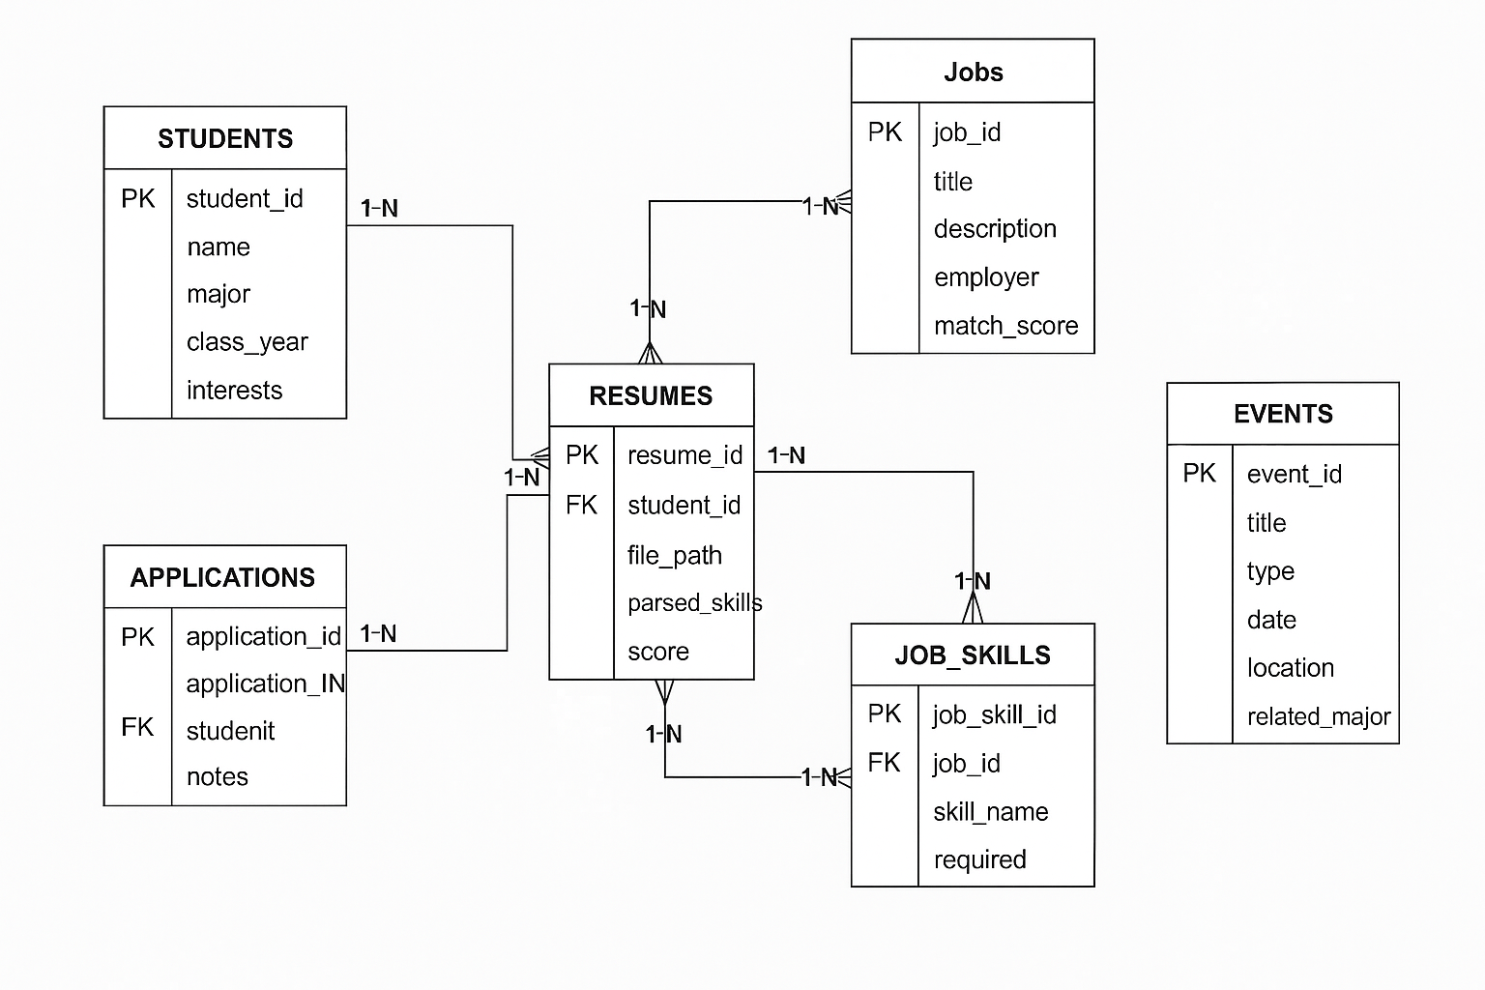

Assumptions
Technical Assumptions
- All team members have access to required software.
- The programming languages chosen will be sufficient for the project.
- Hardware is available and reliable for all members.
- Frameworks or external dependencies will remain stable and supported.
Project/Scope Assumptions
- Requirements will not change mid-project.
- The scope provided is the scope that will be evaluated.
- Deadlines given by the instructor will remain fixed.
Team/Collaboration Assumptions
- Each team member will contribute their share of work.
- Communication(GitHub, iMessage)
- Each team member will have their assigned tasks completed on time.
- Everyone has consistent availability for team meetings
End-User Assumptions
- Users will test the system in expected environment
- Each team member will have common technical knowledge needed to operate the system.

